**Introduction**

International Panel on Climate Change (IPCC) has proclaimed anthropogenic emissions as the primary global warming trigger, despite the crucial role of positive feedbacks within Earth’s system accelerating the process (IPCC, 2013). The rise of near-surface air temperature leads to increased humidity, the effect of which poses a direct threat to human health by increasing the severity and exposure of heat stress (Lundgren, 2013). The human body’s evaporative cooling is an effective instrument for reducing its exposure to heat stress even in severely hot environments given low relative humidity levels. However, when the human body is exposed to hot temperatures and high moisture levels simultaneously, evaporative cooling becomes less efficient, leading to severe heat-humidity health risks.

The Wet Bulb Temperature (WBT) is the most widely used measure of dangerous heat-humidity combinations, calculated as a nonlinear function of relative humidity and near-surface air temperature (Raymond, 2020). It represents the minimum temperature to which the human body could drop via sweat, thus has direct physiological relevance to heat stress. The standard internal temperature of the human body is 36.7 +-5oC. Thus when surrounding WBT reaches 35oC, the effectiveness of evaporating cooling drops significantly, leading to heat accumulation in the body. This threshold is considered as an ‘unliveable environment under sustained exposure’ in the absence of artificial cooling (Pal, 2015).

Nevertheless, heat-related mortality and morbidity cases were recorded at WBT of much lower values due to internal heat generated by the human body during physical activities. For example, during the 2003 European and 2010 Russian heatwaves, maximum WBT values were 28oC, problematising the definition of upper survivability limit. NOAA acknowledged that severe impacts on human health, particularly with pre-existing conditions, can occur at WBT values as low as 26oC (NOAA, 2020)

High WBT is highest in mid-latitude areas, such as South-East Asia, Northeast India, and West Africa, developing economies highly dependent on intensive manual labour (Willett, 2017). Dunne (2013) demonstrated that human labour capacity reduces by 60% during peak annual heat stress, suggesting that countries at the highest risk of raising WBT are also at risk of economic decline. Nevertheless, some of the most developed regions of the world - Southeast U.S. has been indicated as ‘high heat stress risk’ geolocation that is projected to become even more severe (2.37-4.4oC WBT increase) according to highest emission scenario -RCP8.5 of CMIP5 models (Coffel, 2020).

This research aims to expand the knowledge on WBT in the USA by looking at the recent two decades of the 21st century and establishing the relationship between near-surface atmospheric temperatures and WBT. To reveal that heat stress severity is dependent on human behaviour, two contrasting shared socio-economic pathways (SSPs) from the most recently launched CMIP6 climate models - SSP1-2.6 (lowest emission scenario) and SSP5-8.5(highest emission scenario) will be used to expose potential trajectories of WBT in the USA during the 21st century.

**Methodology**

Only period of May-September was analysed to highlight the maximum health risks, occurring during summer period (Koteswara, 2020). Historical records (2000-2020) of relative humidity and near-surface temperature variables were downloaded from Climate Engine. Firstly, spatially averaged across the whole USA territory datasets were cleaned from duplicates, null values and fed into Equation 1 to calculate WBT.

Equation 1: Wet Bulb Temperature formula



A scatterplot and Pearson's correlation test was used to determine the relationship of T and WBT, while a time-series plot examined temporal dynamics. Figure 1 illustrates data transformation performed in QGIS—averaging over 5-year segments allowed to focus on significant changes in WBT distribution instead of detecting inter-annual fluctuations.

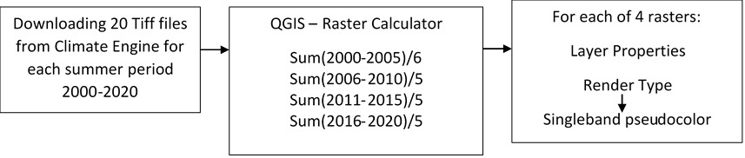

Areas of heat stress risk were classified with -26oC threshold, according to a recent NOAA report (2020) and recorded fatal heat stress cases at WBT below 35oC threshold (Im, 2017). Raster files were reclassified in QGIS using Raster Calculator; the total area covered was calculated with Unique values report tool. The change of area was calculated and recorded in percentages. Each raster file was then converted to CSV in R and tested for statistically significant differences with the Kruskal Wallis test.

Climatic scenarios were chosen to represent the type of human impact on global warming – rising and accelerating emissions at SSP5-8.5 and significant emission decrease at SSP1-2.6. FGOALS-f3-L model was selected for analysis at 100m resolution and monthly frequency, as at lower scales, files exceeded the RAM capacity of the computer used to conduct this research. As in the methodology of Tobin (2018), data was split into near-future (2021-2047), mid-century (2047-2074) and late-century (2075-2100). The area above 26oC was calculated for each period at both scenarios, and differences between periods and scenarios were tested.

**Results**

WBT and temperature variables are strongly related (Figure 1&2) – 0.96 Pearson’s correlation coefficient, which is expected as WBT is a function of the latter variable. Figure 2 indicates that WBT is always lower than temperature – 2.35oC on average, and there is no increasing trend of both variables at spatially averaged across the whole USA territory scale. Figure 3 shows the spatial distributions of WBT and temperature during each 5-year segment and their spatial covariance coefficients. Spatial covariance is weaker than Pearson’s due to the relative humidity component on WBT. Thus, locations of high temperature do not directly correspond to locations of high WBT. Areas in Nevada and Arizona are the most visually prominent example of this spatial variables mismatch. Those are located inland and have low humidity levels but high near-surface temperature levels, yielding lower WBT values.

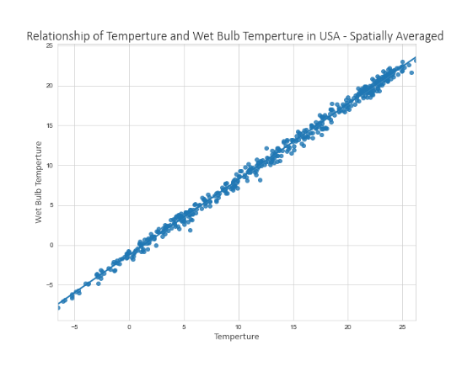

Figure 1: Relationship of T and WBT

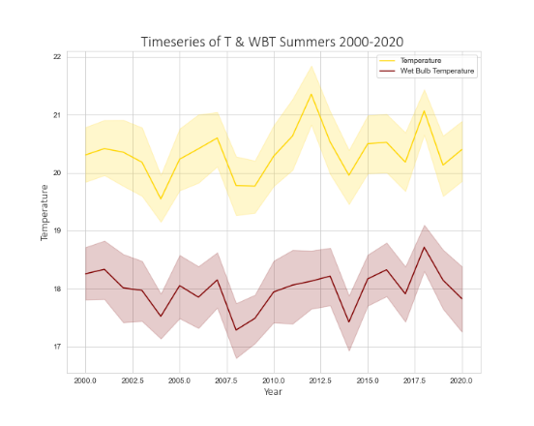

Figure : Temporal dynamics of T and WBT summers 2000-2020



Figure : Spatial distribution of temperature and WBT across USA 2000-2020



Table : Historical WBT data descriptive statistics

Figure : Results of Kruskal Wallis tests between all 5-year segments 2000-2020

Figure 4 shows the data distribution derived from raster files for each 5-year segment, where each pixel was recorded as a data point. There are no statistically significant differences and Table 1 outlines that means, medians and standard deviations remain stable during periods examined. There is a slight increase of maximum values between 2006-2010 and 2016-2020, yet their proportion is too low to yield significant differences between years.

Nevertheless, Figures 5 and 6 show that areas experiencing WBT of 26oC and above increased throughout the last two decades. The locations of heat stress risk are the southeast coast, particularly Florida, Louisiana, and part of Texas, as their proximity to the Gulf of Mexico yields dangerous combinations of high heat and humidity. The growth rate is inconsistent, and there is a slowdown between 2006-2010 and 2011-2016, yet the growth of 14.3% and 14.7% between the remaining 5-year segment is a sign of increasing heat stress risk.

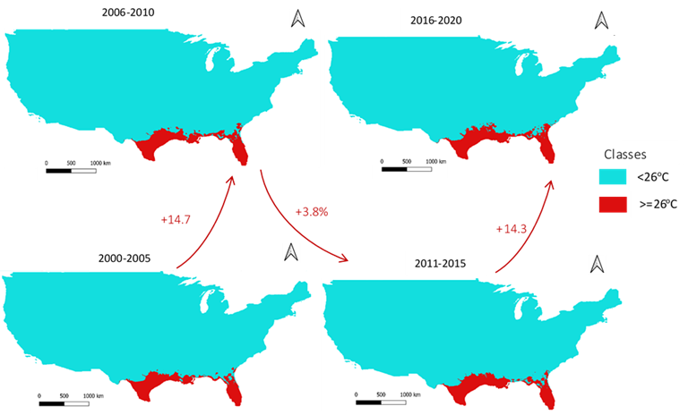

Figure 6: Areas with WBT above 26oC and their proportional growth

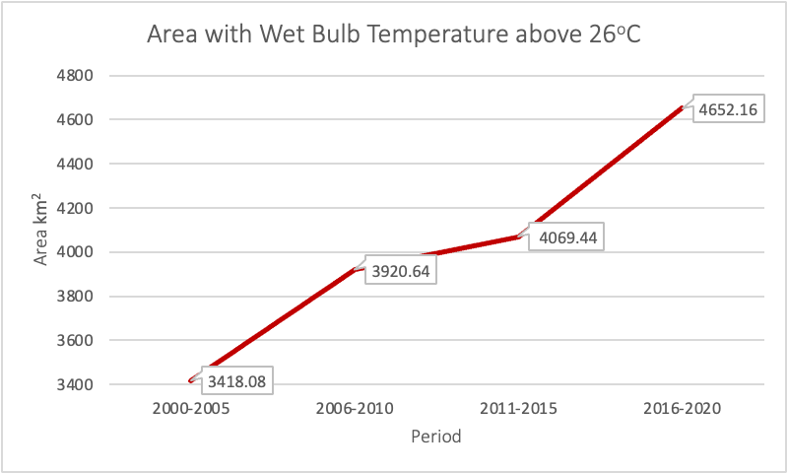

Figure5: Areas with WBT above 26oC 2000-2006

SSP1-2.6 showe that WBT will rise rapidly in the near future, with mean WBT increasing by up to 3oC during 2021-2047 and maximum values by up to 6oC – Table 2 & Figure 7. Temperature is expected to vary more, as standard deviation spiked by approximately 2 points, indicating a potential rise in heat-wave frequency. The surface area where WBT is 26oC or above is 5878.25km2, a 26% rise since the last 5-year segment of historical data, indicating rapid acceleration of heat stress exposure during near future period SSP1-2.6 scenario. Nevertheless, after a significant increase of WBT and corresponding heat stress risk, SSP1-2.6 projectsa rapid decline of WBT to values below heat stress risk threshold – 26oC. Kruskal Wallis test results confirm that transition is statistically significant, as near-future data distribution is different from mid-century and late-century. Simultaneously, the two latter periods are not different, indicating stabilization of warming.

 Each period is significantly different between scenarios, and there are significant differences between periods at SSP5-8.5. A gradual acceleration of WBT rise, with 1.2oC and 0.7 oC increase of means at near-future and mid-century correspondingly, followed by +3.9oC during late century is expected at SSP5-8.5. The area under heat stress risk (>=26oC) is 4.6% less for the near future than in the most recent five years. However, the rising trend is expected to accelerate significantly between mid-century and late-century.



Table : SSP1-2.6 descriptive statistics

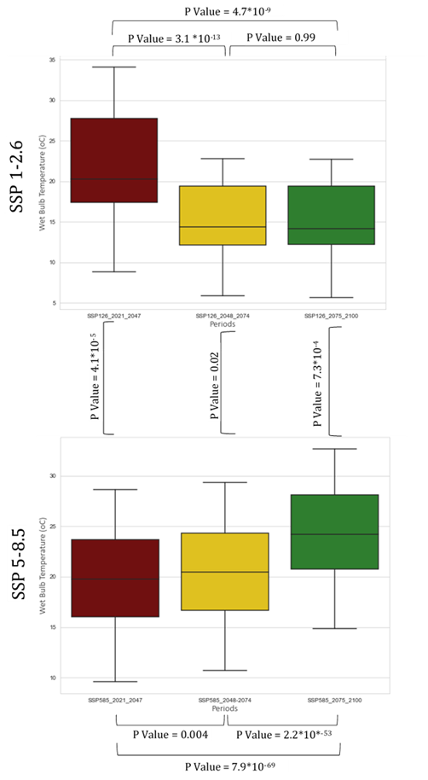

Figure 7: Results of Kruskal Wallis test comparing WBT distribution between time periods within and between climatic scenarios

Table : SSP5-8.5 descriptive statistics

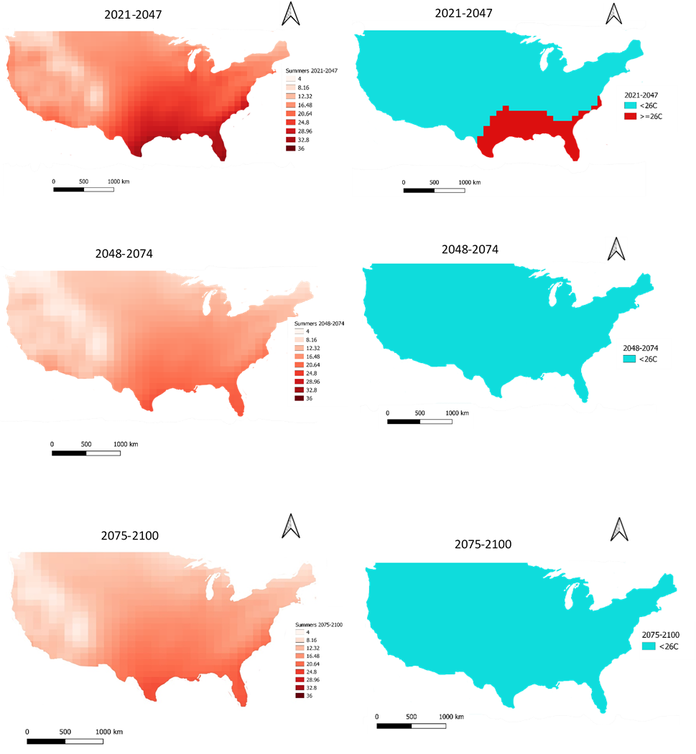

**Discussion**

The analysis of historical data revealed that there is no warming trend at the spatially averaged scale in the USA. However, the area under heat-stress risk was gradually increasing for two decades. These disparities are likely due to the high range of temperature values in the USA, leading to cancelling out potentially significant differences between periods in areas most affected by global warming. Therefore, an improvement to the methodology would be data segmentation by regions, as by Raymond (2020), allowing to reveal heat-stress risk within various climatic zones of the USA. Almost the whole territory of Florida has WBT values above 26oC, indicating that area is at high risk of heat stress. EPA (2016) reported that Florida has already warmed by 1oC in the last century and increasing precipitation + 27% since 1958 and sea-level rise at a rate of 1 inch per three years (Saha, 2011), yielding dangerous WBT values. According to Raymond (2020), revealing the strength of humidity influence on WBT current trends indicate high heat-stress risk that will be amplified in future.

Most importantly, this study statistically proved that humans could regulate the global warming process by adjusting greenhouse gas emissions. The projections of SSP5-8.5 are consistent with findings of Newth (2018) – 2-4.5oC rise of WBT by the end of mid-century (2070-2080), indicating the reliability of the model chosen for this research. However, the use of only one climate model in this study is a significant limitation, as typically ensemble of at least 50 models is used to provide reliable findings in climate science (Stott, 2007). Nevertheless, this study provided a valuable contribution to analyzing the projections of the FGOALS-f3-L model. Thus the influence of its data would be better understood if used in the ensemble for further research. While monthly frequency data did not show WBT rise to 35oC, considered unlivable environment threshold, there is a high probability of these values to occur daily or hourly frequency, given that the maximum monthly average is 2oC lower during the late-century at SSP5-8.5. Dahl (2019) showed that under RCP8.5, 7.8 days of severe heat stress is expected during mid-century and 15.3 during the late century. Thus, looking at the daily frequency data of the FGOALS-f3-L model, research findings can be validated further.

SSP1-2.6 showed much more rapid dynamics of WBT changes in the USA, with 26% more exposure to heat stress, which is a trade-off of lowering emissions rapidly. Modifying socio-economic behaviours and developing energy-saving technology on a global scale in a short time frame leads initial rise of emissions and corresponding warming amplified by positive feedback (Li, 2017). For example, increasing the proportion of renewable energy through wind farm installation requires large initial ‘embedded CO2’ in steel, concrete, and transportation of turbines themselves, however on a larger temporal scale, emission breakeven in the first quarter windfarm lifetime (Guezuraga, 2012). Still, complete elimination of WBT values above the dangerous threshold is a strong incentive for such investments.

**Conclusion**

This research revealed that heat stress exposure increased in the USA during the last two decades of the 21st. The areas of risk are Florida and the South-east coast around the Gulf of Mexico, where high temperature and relative humidity levels create dangerous heat-related health risks. Two contrasting scenarios revealed that if greenhouse emissions continue to rise, the exposure to heat stress and severity of associated health risks will grow progressively during the 21st century. This trend would require significant investments in health care or adaptation measures, such as air conditioning, putting most financially vulnerable population groups not only at health risk but also a financial burden. Alternatively, by lowering emissions and coping with the initial WBT rise, it will be possible to eliminate heat-related risk. This research acknowledges that looking at two extreme possibilities of future climate change is a critical limitation. Nevertheless, this approach illustrates the maximum potential of human behaviour adjustment on limiting or maximizing heat-related health risks.